11-HARVEST

The HARVEST module determines what happens to the live, dead, and stable pools when a stand grid cell is harvested (Figure 11-1). When a harvest occurs, all the cohorts are potentially impacted. The user specifies the harvest type, whether the new cohort area created, the utilization level, and the number of patches in a stand grid cell the harvest creates. While it is possible to change the area of new cohort space over time, we encourage the user to be conservative. The output variables of this module are used to modify the state variables in the GROWTH and the DECOMPOSE modules. Harvest is invoked the year a harvest is specified and can be for any number of cells or species. Harvest calculations are made following the calculation of changes associated with normal growth and decomposition.

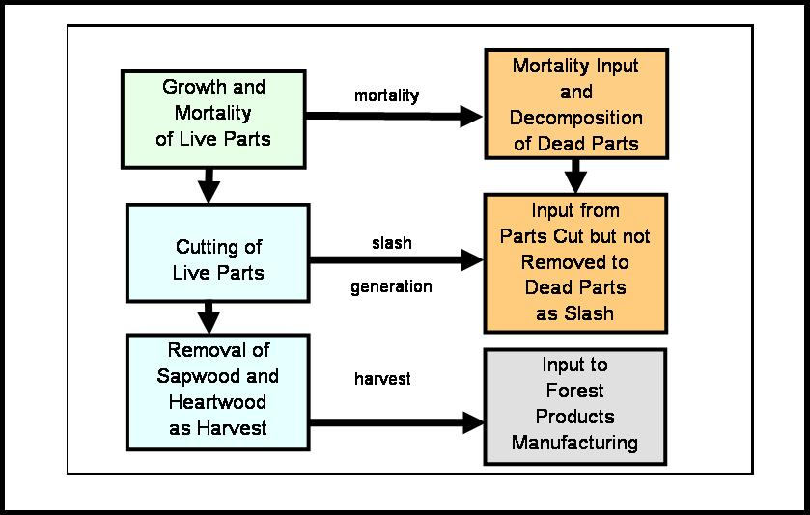

Figure 11-1. Processes occurring when a harvest occurs in the LANDCARB model.

Harvests can either create a new cohort (all the plant layers are killed) or if a new cohort is not created, then how existing cohorts are impacted. Specifically, to mimic partial harvest of a stand grid cell it is possible to use one of two options:

1) if plant layers are not completely killed by the harvest, the new cohort area is set to 0, and the utilization level indicates which plant layers are influenced and what degree. All cohorts would be effected by this kind of harvest;

2) if the plant layers are killed by the harvest, then area for a new cohort is created and plant layers are recolonized. Depending on the area of new cohort space created, some of the cohorts will be effected and other will not.

In the latter case the user needs to specify the number of patches the disturbance creates. There is a minimum number of patches that a harvest creates. If half the stand is harvested, then one needs to have at least two patches. If one-quarter is harvested, then one needs at least four patches. The number of patches can be any multiple of the minimum number of patches. The number of patches determines the mean distance between cohorts and the light levels recieved, but does not influence the number of cohorts that are modeled.

LANDCARB uses the concept of a virtual gridwork of substand cells within stand grid cells (Figure 11-2). In STANDCARB this substand gridwok of cells is explicit. The number of cells in the LANDCARB substand gridwork is set by the minimum number of patches implied by the area of new cohort space created by the harvest. If this disturbance pattern is repeated, then in time the number of cohorts in a stand grid cell will be the same as the minimum number of patches. This prevents a situation where the number of cohorts increases without limit with each disturbance cycle.

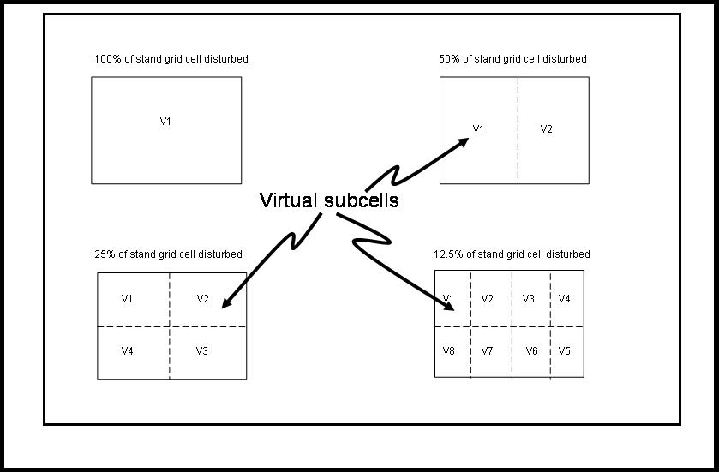

Figure 11-2. Examples of virtual subcells used by the LANDCARB model when a partial harvest occurs in a stant grid cell.

When a harvest occurs certain of the existing “patches” can be harvested. The user sets whether the youngest, oldest, or a random set of patches is harvested. If the oldest is selected, then an area equal to the “patch” size is harvested creating a new cohort. Suppose one starts with one cohort in a stand grid cell and 25% of the stand grid cell will be harvested in 4 patches. The first round of harvest would result in two cohorts; the original cohort would occupy 3 “virtual patches” and the new cohort would occupy 1 “patch”. After the second round of harvest there would be three cohorts, two occupying one “patch” and one occupying two “virtual patches”. With another round of harvest there would be four cohorts, each one occupying one “patch”. Yet another round of harvest and there still would be 4 cohorts each in one “patch”, but the original cohort would have disappeared. In the case where the youngest cohort is selected then there would always be two cohorts, as the youngest is always harvested. The first cohort would always occupy 3 “virtual patches” and the youngest one “patch”.

The utilization standards (i.e., fraction of the bole removed) for each type of harvest is defined by the Harvest.drv file. The schedule of harvests for stand grid cells is given in the HarvIntLC.drv file.

If harvesting occurs on a stand grid cell in a given simulation year, then the Harvest module determines which activity is to occur as defined by the HarvInt.drv file. Possible activities include: precommercial thinning, commercial thinning, clear-cut harvest and timber salvage. All of these treatments except timber salvage impact the live tree layers and may or may not lead to a new cohort being formed. Precommercial thinning is defined as a thinning of the trees where all the bole material is left on the site as slash. In a commercial thinning, a proportion of the boles in a cohort is removed. In a clear-cut all the bole material for a cohort is cut. Timber salvage impacts the salvageable sapwood and heartwood and never leads to a new cohort being formed. For live trees if a harvest occurs and a new cohort is not formed, then harvest may be performed on the upper or lower tree layer, separately or together. When a new cohort is formed by harvest, then both the upper and lower tree layers are completely cut.

All the harvest activities result in the production of dead plant parts that are removed from the GROWTH module and added to the decomposition pools in the Decompose module. In addition, some of the bole material is removed as harvested mass.

The files used by this module is Harvest.drv and HarvIntLC.drv.

Convert Function.

This function converts the parameters from the Harvest.prm file from percentages to proportions:

AmtCut=AmtCut/100

AmtTake=AmtTake/100

where AmtCut is the fraction of the tree bole volume that is cut and AmtTake is the fraction of the boles that are cut that is taken as harvested material.

Harvest Function.

Once the type and timing of a harvest treatment has been determined from the HarvIntLC.drv file the Harvest function calculates the amount of sapwood and heartwood mass removed, the mass of sapwood and heartwood left in tops and stumps, the mass of salvageable sapwood and heartwood removed and the mass of dead material left as slash that was created by the harvest. Regardless of the type of harvest specified, the mass plant parts remaining after harvest is calculated as:

PartNew= (1-AmtCut)*PartOld

where

PartNew and PartOld are the masses of plant parts after and before the harvest. Whenever a new cohort is to be formed, AmtCut is set to 1.0 (i.e., 100%).

Sapwood and heartwood can be removed from the site during harvest. The mass of sapwood and heartwood that is removed (PartTaken) from a cohort is calculated as:

PartTaken= AmtCut*AmtTake*Part

where AmtCut is the proportion of the tree biomass cut and AmtTake is the proportion of the bole mass that is harvested and exported from the site to become forest products, and Part is either sapwood or heartwood mass. In most cases, AmtTake for precommercial thinning is set to zero.

We have used the convention that the input of detritus mass associated with harvest is named for the detritus pool with the addition of Harv (e.g., sapwood left to decompose after harvest is called DeadSapwoodHarv). The amount of sapwood and heartwood mass added to the DeadSapwood and DeadHeartwood pools due to harvesting is calculated as:

PoolHarv = AmtCut*(1-AmtTake)*Part

where Pool is either DeadSapwood or DeadHeartwood, and Part is either Sapwood or Heartwood mass, respectively.

For other plant parts such as branches and coarse roots, the model assumes there is no export from the site. The mass of the non-bole parts transferred to their appropriate dead pool by commercial thinning is calculated as:

PoolHarv=AmtCut*Part

where Pool is the detrital pool the material is being added to (i.e., DeadFoliage, DeadFineRoots, DeadBranch, and DeadCoarseRoots) and Part is the corresponding plant part mass (i.e., Foliage, FineRoots, Branches, and CoarseRoots).

When there is a salvage of timber the user specifies a proportion of the salvageable dead sapwood and heartwood that can be removed. The mass salvageable dead wood remaining after harvest is calculated as:

PoolNew= (1-AmtRemoved)*PoolOld

where

PartNew and PartOld are the masses of salvageable dead wood pools after and before the salvage.

The amount removed in a salvage is:

PoolTaken= (AmtRemoved)*PoolOld

Volume Function.

This function converts the mass of boles harvested from a cohort for a given year to wood volume. The volume of bole wood removed in harvest is estimated from the sapwood and heartwood mass removed and the fraction of boles in wood (WoodPer), and the wood density (WoodDen) for the given species harvested in a cohort. The parameters WoodPer and WoodDen are stored in the Growth.prm file.

The total mass removed in boles for a tree layer in a cell by harvest is:

Harvest=SapwoodTaken + HeartwoodTaken

The mass of wood (Wood) in the harvested boles is:

Wood=Harvest*WoodPer/100

where WoodPer is the percentage of the bole mass that is wood as opposed to bark (Wilson et al.1987). The volume of wood (HarvVol) is calculated by dividing the wood mass (Wood) by the wood density (WoodDen):

HarvVol=Wood/WoodDen

The values of wood density for each species is based on Marglin and Wahlgren (1972) and Wilson et al. (1987).

The total mass removed as salvaged boles in for a cohort by salvage is:

Harvest=DeadSapwoodTaken + DeadHeartwoodTaken

The fraction of wood (Wood) in the salvaged boles is:

WoodSalvaged=Harvest*WoodPer/100

where WoodPer is the percentage of the bole mass that is wood as opposed to bark (Wilson et al.1987). The volume of salvaged wood (SalvageVol) is calculated by dividing the wood mass (Wood) by the wood density (WoodDen):

SalvageVol=Wood/(0.9*WoodDen)

Where the wood density is decreased to account for decay.

